**Pei Hwa Secondary School**

**Sec 2 Subject Combination Exercise**

**URL : https://peihwa.schoolhub.sg**

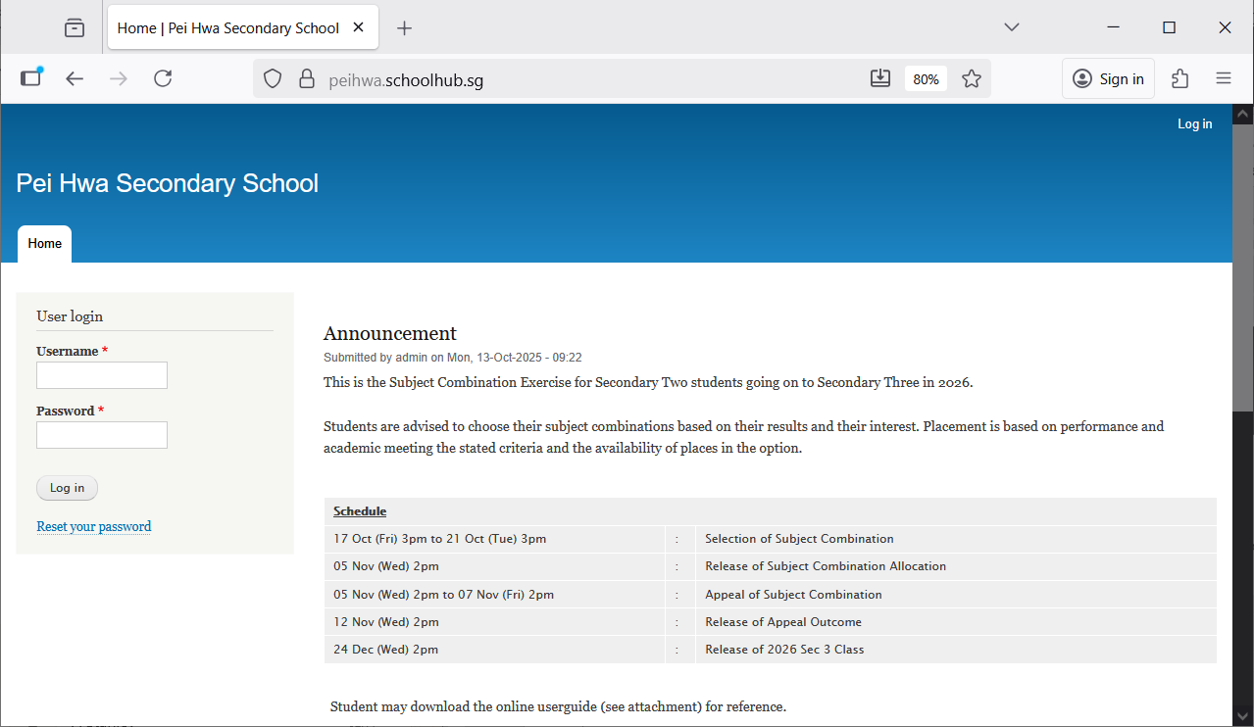

Steps

* Enter Username
* Enter Password
* Click Login

## Register Choices

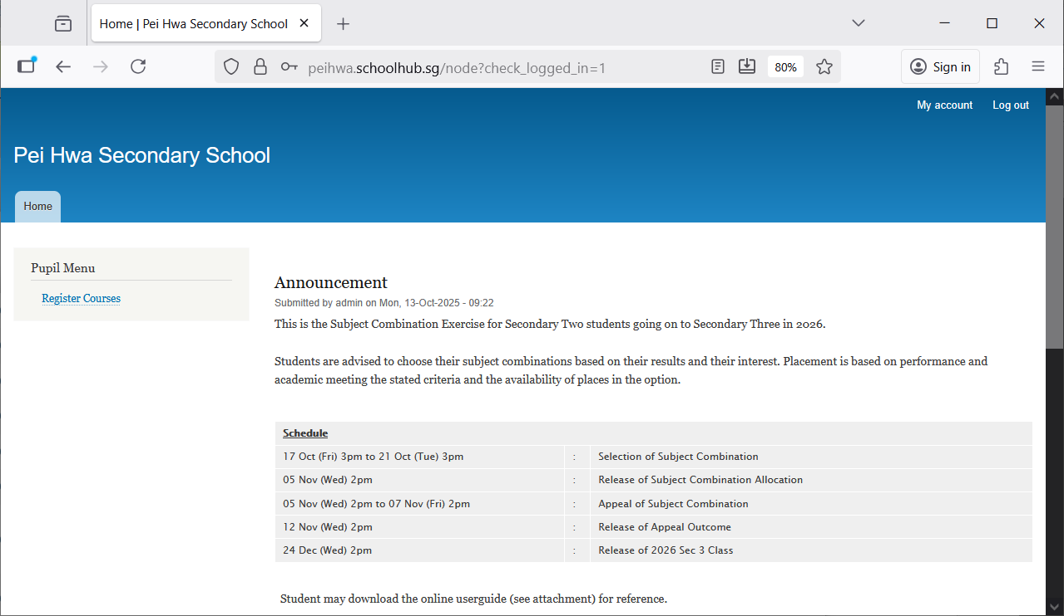

Steps

* Click Register Choices

The subjects are divided into different categories:

* EL - Compulsory
* MT - Compulsory
* MATH - Compulsory
* C/HUMANITIES
* SCIENCE
* OTHERS

You will need to rank all the subjects within each category. Please note that only subjects offered to you will be available for you to rank. For categories with only ONE Subject (Compulsory), it will be automatically rank 1.

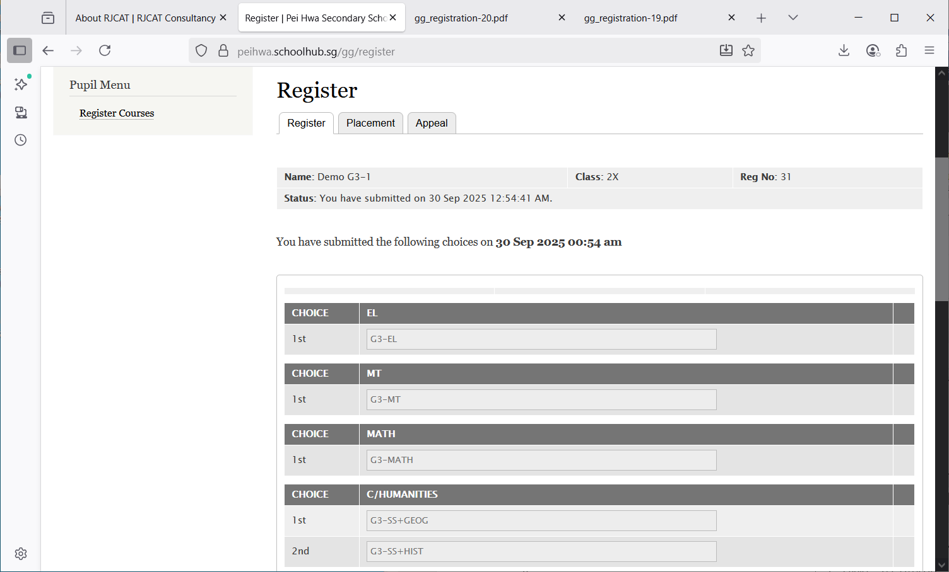

1st Choice = G3-SS+HIST

2nd Choice = G3-SS+GEOG

Hold and Drag to change your choices.  
for example:

Change G3-SS-Hist to 1st choice  
Change G3-SS+Geog to 2nd Choice

After changes:

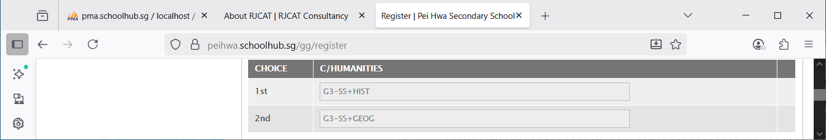

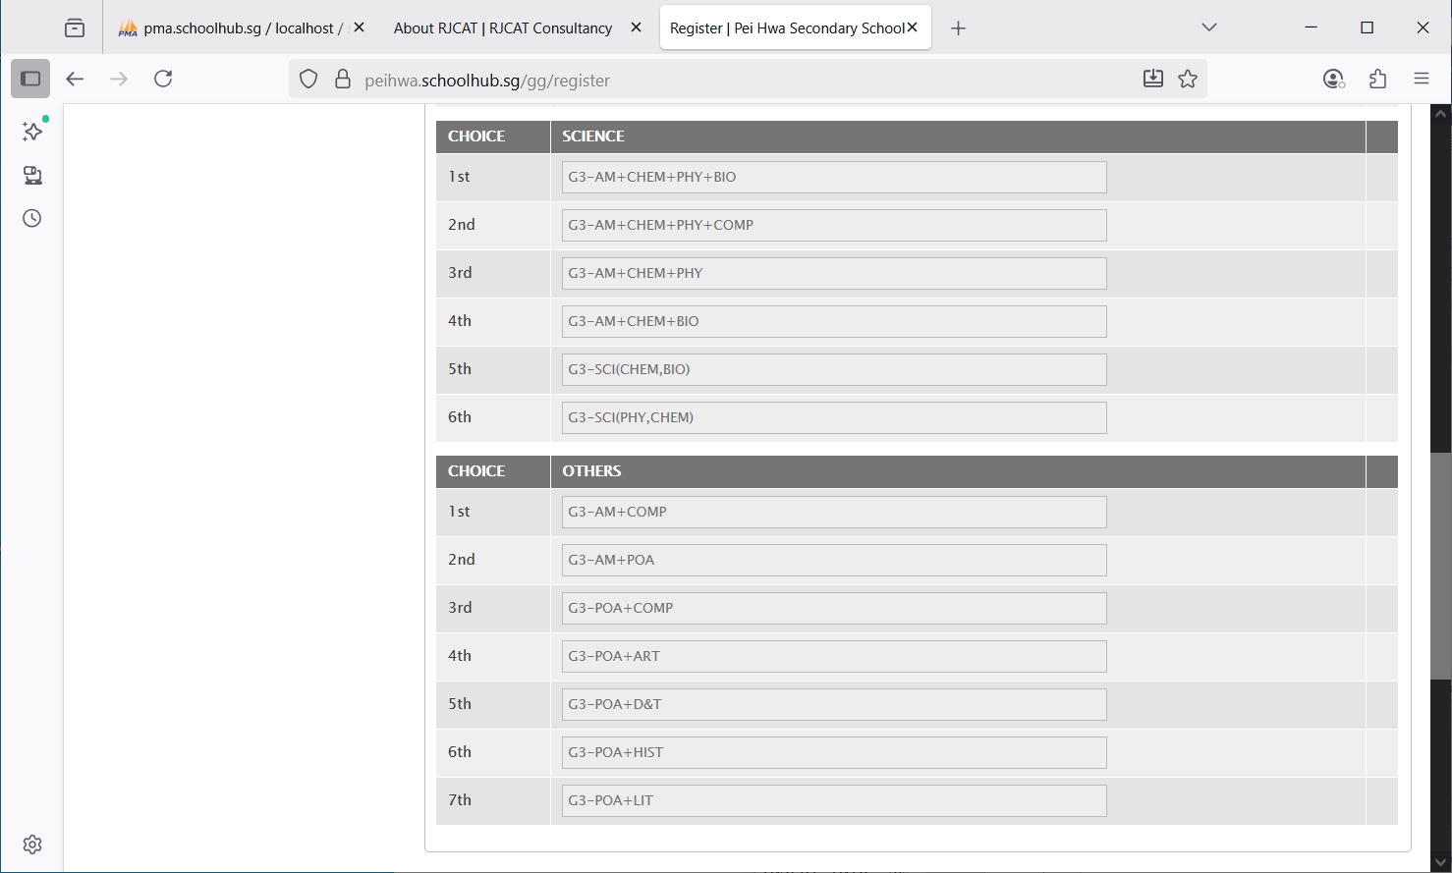

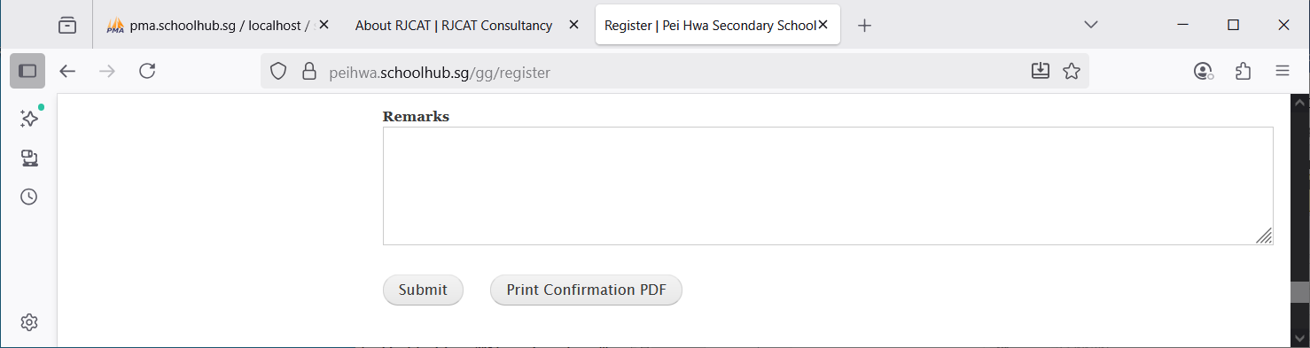

Click Submit to save your choices. You may change them before the closing date.

Click Print Confirmation PDF to get a copy of the PDF for your reference.

Enter any remark you wish to communicate with your teacher

## Sample Confirmation Slip

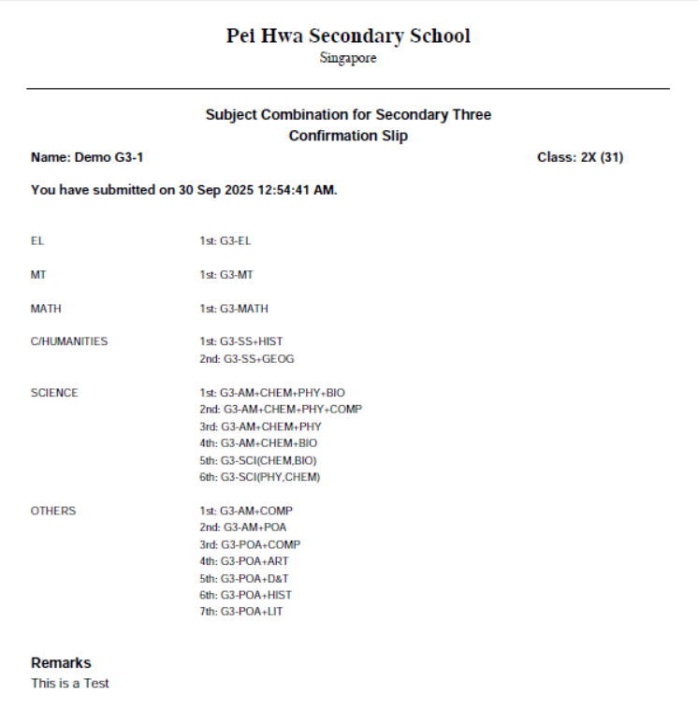

## Check Subject Allocation (Placement)

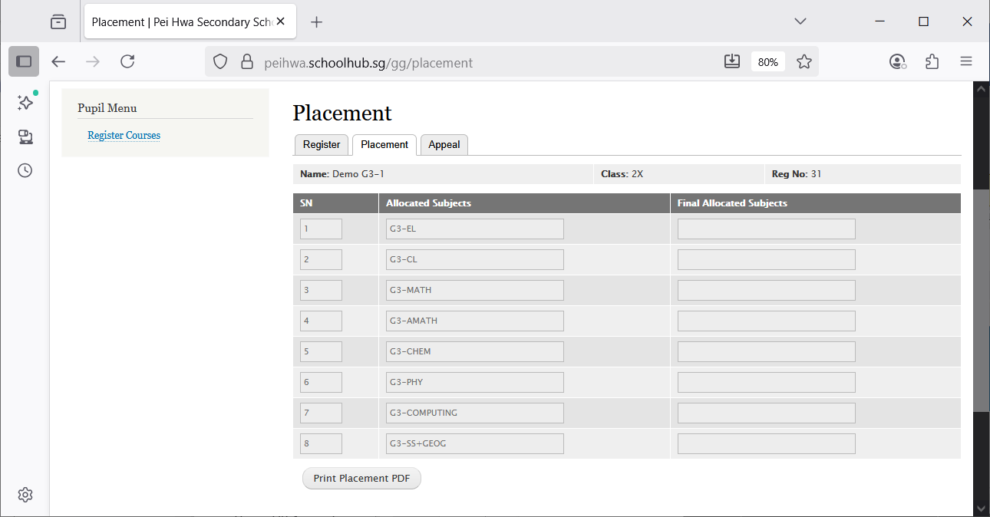

You may print a copy for your reference

## Appeals

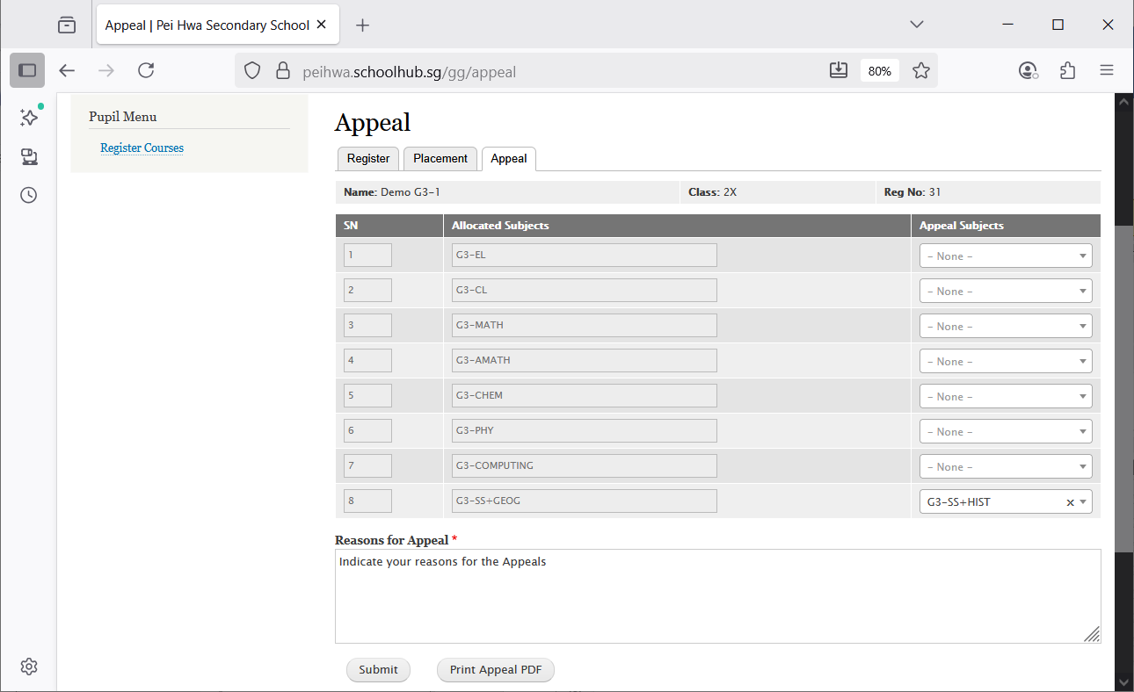

Indicate reasons for the Appeal

Subject to Appeal for to replace G3-SS+GEOG

You may print a copy for your reference

## Check Final Subject Allocation

If there is no APPEAL, the Final Allocated Subjects will be the same as the Original Allocated Subjects.

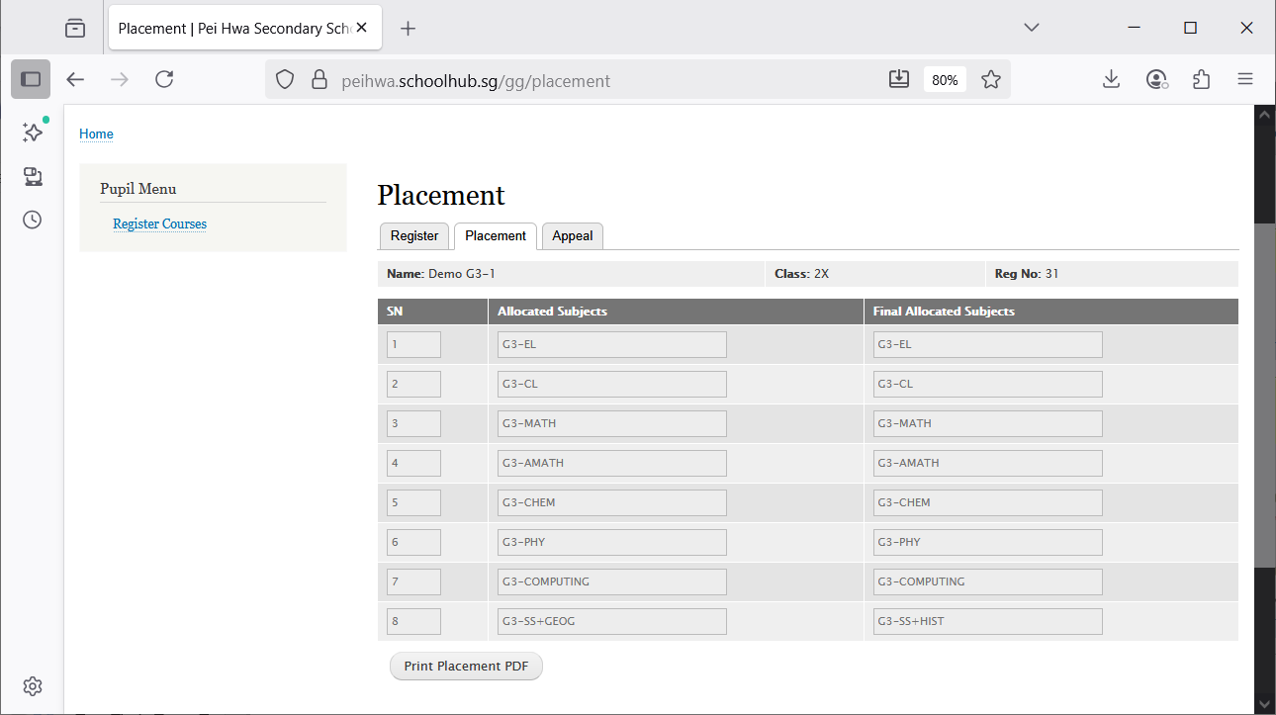

Original Allocated Subjects

Final Allocated Subjects

You may print a copy for your reference